Supplementary Information
Protein fractions using the Ni-IDA resin on the Profinia™ purification system. Also included are typical enzyme protein concentration.
M

Total protein

Insoluble

Loaded

Flowthrough

Wash1

Wash 2

Eluate
- Nucleotide diphosphate kinase

250
130

100

\\\\
70
55

35

25

15

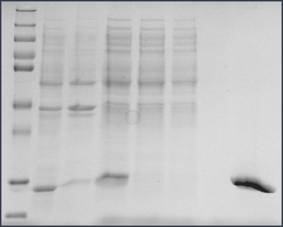
M
Loaded
Flowthrough
Wash 1
Wash 2
Eluate 1
Eluate 2
Eluate 3
14.4
- Histidine Kinase

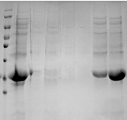
250
130

100

\\\\

70

55

35

25

15

M

AK Loaded

AK Flowthrough

AK Wash 1
AK Wash 2
AK Wash 3
AK Eluate

GK Loaded

GK Flowthrough

GK Wash 1
GK Wash 2

GK Wash 3

GK Eluate
33.4
- Acetate and glycerol kinase
250
130

100

\\\\

70

55

35

25

15

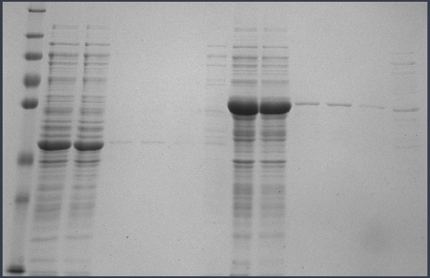
43.7 AK
58.2 GK
SDS-PAGE gels of the Mtb his-tagged kinases purified from E. coli BL21 (DE3).. A) Nucleotide diphosphate kinase. B) Histidine kinase. C) Acetate kinase and Glycerol kinase. M = (PageRuler™ Plus Pre-stained Protein Ladder, Fermentas) and the sizes of this marker are indicated to the left of the gels. The blue arrows actual protein masses in kDA.
D) Thiamine monophosphate kinase

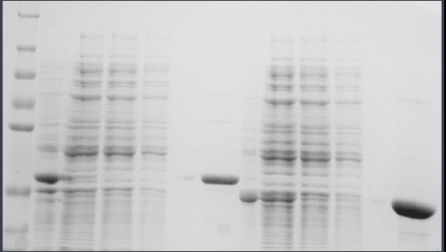
M
Insoluble
Loaded
Flowthrough
Wash 1
Wash 2
Eluate
250

130

100

\\\\

70

55

35

25

32.3 RBKS
36.4 ThiL
- Aspartokinase
250
130

100

\\\\

70

55

35

25

15

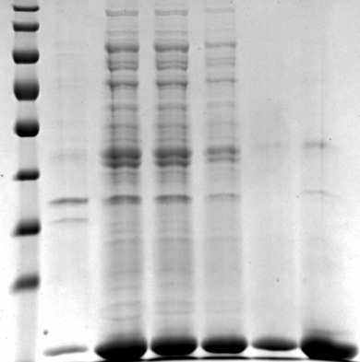
M
Loaded
Flowthrough
Wash 1
Wash 2
Eluate
18 (beta)
44.6 (alpha)
- Shikimate kinase
250
130

100

\\\\

70

55

35

25

15

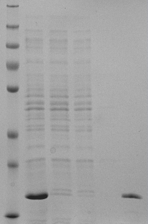
20.7
SDS-PAGE gels of the Mtb his-tagged kinases purified from E. coli BL21 (DE3). D) Thiamine monophosphate kianse (T) and Ribokinase (R). E) Aspartokinase. F) Skikimate kinase. M = represents the molecular mass marker (PageRuler™ Plus Pre-stained Protein Ladder, Fermentas. USA) The blue arrows actual protein masses in kDA.
M

Insoluble
T Loaded

T Flowthrough
T Wash 1

T Wash
2 Eluate

R Insoluble
R Loaded

R Flowthrough
R Wash 1

R Wash 2

R Eluate

Determination of Protein Quantitation
The Qubit® 2.0 Fluorometer quantitated the purified proteins swiftly and accurately. This molecular technique provided a simple way to determine the concentration of the available protein for further analysis. The results are presented in Table below.

Concentration of purified kinase proteins (presented in µg/ml)
Kinase | Enzyme Concentration (µg/ml)
NDK | 1480
HSK | 935
AK | 390
GK | 348
ThiL | 755
RBKS | 800
AsK | 1128
SK | 2030

The use of sequential purification techniques were intended to generate smaller amounts of purer active protein. The concentration levels of protein expression obtained through these sequential protein purification techniques and systems were suitable for further functional analysis and screening protocols.

ACETATE KINASE
SEQUENCE (K)MLAEDGIDLQTcGLVAVGHR Peptide Identification Probability 99.7%
SEQUEST XCorr 4.273295 Seq Delta Cn 0.6725566 X! Tandem 9.130768
Modification. Carbamidomethyl Unique peptides 34 Unique spectra 47 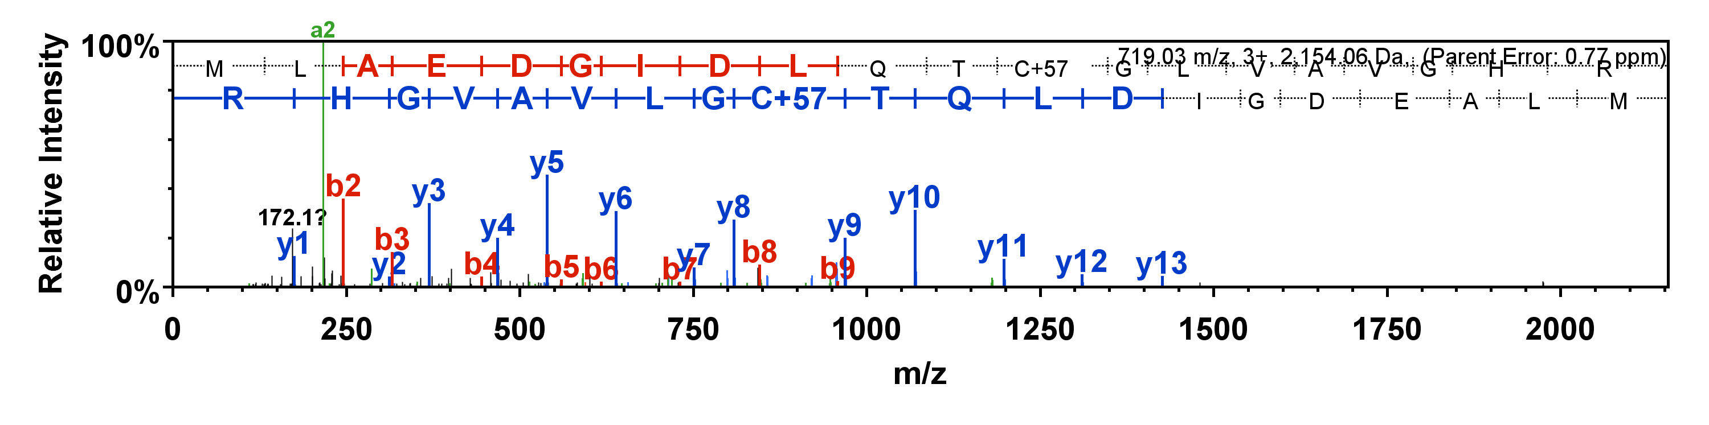
GLYCEROL KINASE
SEQUENCE (R)DQLGIISGAAQSEALAR(Q) Peptide Identification Probability 99.7%
SEQUEST XCorr 4.122187Seq Delta Cn 0.5792115X! Tandem 10.721247
Modification. None Unique peptides 55 Unique spectra 68
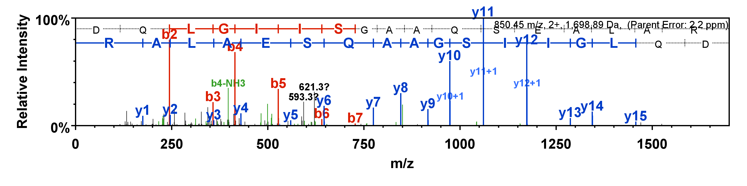
HOMOSERINE KINASE
SEQUENCE (K)GFAVTELTVGEAVR(W) Peptide Identification Probability 100%
SEQUEST XCorr 3.887441 Seq Delta Cn 0.6896717 X! Tandem 8.721247
Modification. None Unique peptides 65 Unique spectra 100
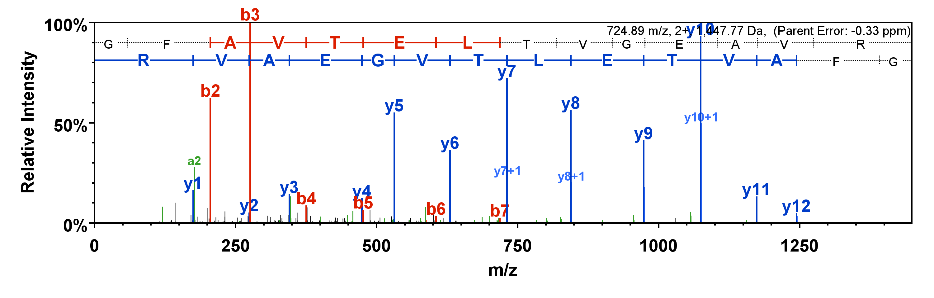

NUCLEOSIDE diPHOSPHATE KINASE
SEQUENCE (R)KGLTIAALQLR(T) Peptide Identification Probability 100%
SEQUEST XCorr 3.86 Seq Delta Cn 0.69 X! Tandem 3.11
Modification. None Unique peptides 11 Unique spectra 18
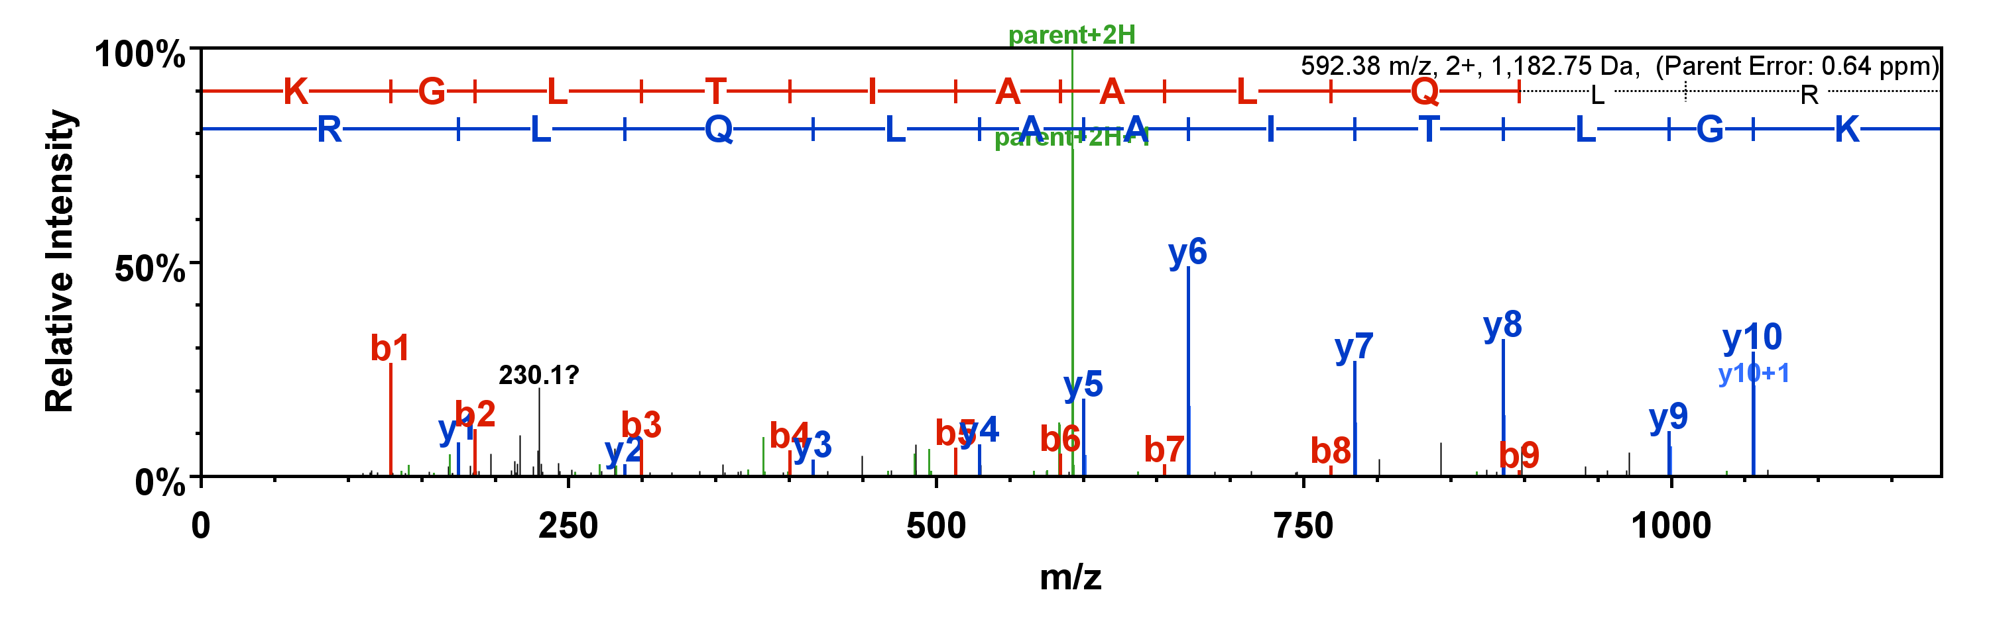
THIANINE MONOPHOSPHATE KINASE
SEQUENCE (R)TVVSTDMLVQDSHFR(L) Peptide Identification Probability 100%
SEQUEST XCorr 1.8 Seq Delta Cn 0.487 X! Tandem 2.89
Modification. None Unique peptides 3 Unique spectra 3
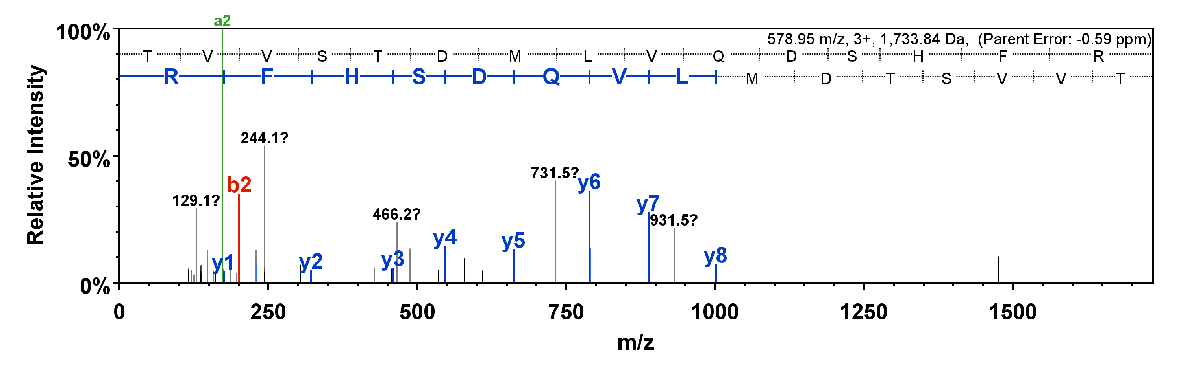
ASPARTOKINASE
SEQUENCE (R)cVEYARRHnIP(V) Peptide Identification Probability 99.7%
SEQUEST XCorr 0.43 Seq Delta Cn -0.1 X! Tandem 0
Modification. None Unique peptides 3 Unique spectra 3

